MOBILEIRON: HOW TO REMOVE MERAKI (OR OTHER MDM) FROM IOS

MobileIron is the Partners Enterprise Mobile Device Management (MDM) solution that allows you to access various Partners resources from a mobile device. Apple only allows for one MDM to be installed on a device at any given time. This guide provides instructions for removing and existing MDM profile (e.g. Meraki) from your device so that you can install MobileIron

Note: for MGH Users using the “Mojo” app, the removal of Meraki will also remove Mojo from your device. After you install MobileIron, however, the you will be automatically prompted to reinstall Mojo.

REMOVAL INSTRUCTIONS
Step 1: Remove your existing Mobile Device Management Configuration
- Open Settings on your iOS device
- Tap on General > Device Management
- Select the Meraki / AirWatch / MaaS360 Management Profile
- Tap on Remove Management
- Enter your device’s passcode to complete the removal

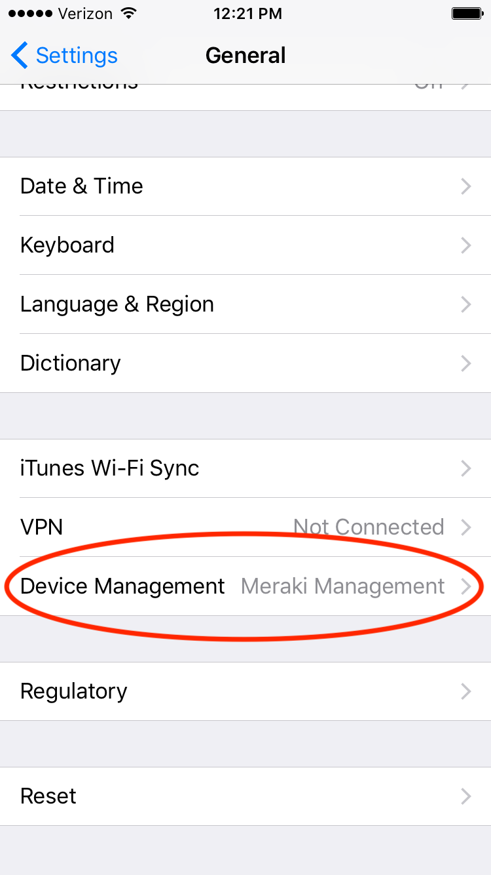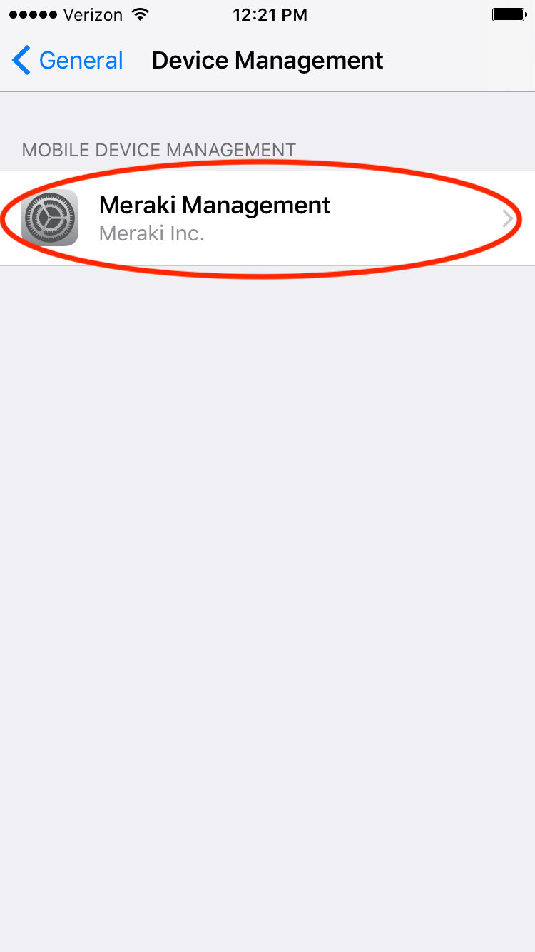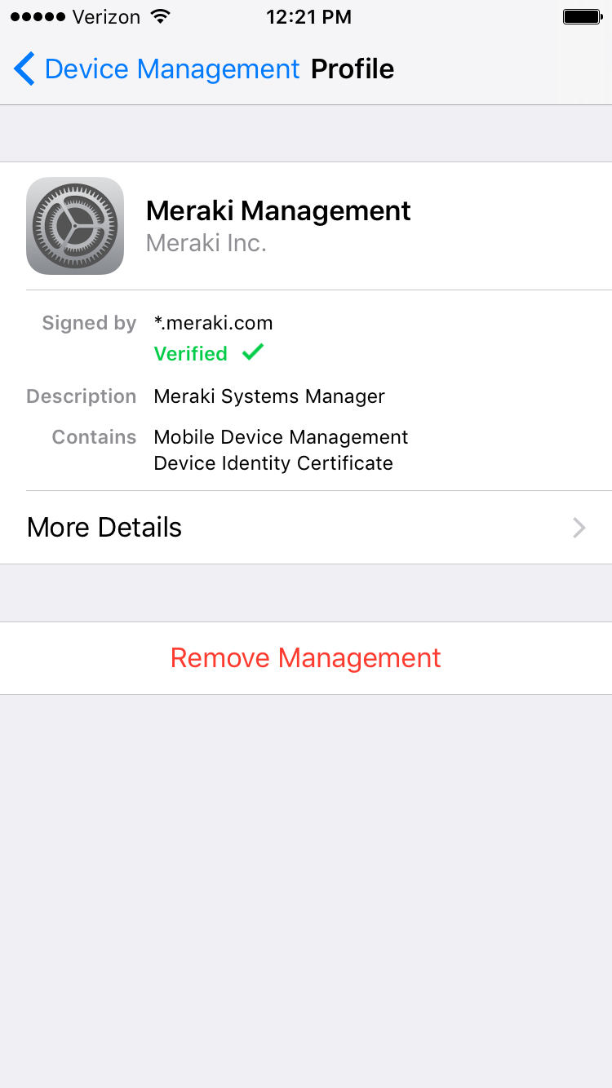

ENROLLING INTO MOBILEIRON
Please download the MobileIron Setup Guide for iOS found on the Partners Service Desk Website

URL: https://partnershealthcare.service-now.com/sys_attachment.do?sys_id=863076e4dbed0f048efbf1431d96190f

FREQUENTLY ASKED QUESTIONS
What should I do if I am an employee of another company and already have MDM installed on my phone?
Please check with your company’s IT department if it is OK to remove their MDM before enrolling in MobileIron

What should I do if I am a Partners Employee but am enrolled in another company’s MDM?
Starting on October 31, 2017, MobileIron will be required on all mobile devices accessing Partners Email. If you want to be able to access your Partners email, you will need to remove the other company’s MDM and enroll into MobileIron

How can I access my Partners Email if I am not able to or do not want to remove a non PHS MobileIron MDM?
Starting on October 31, you will need to access your Partners email via the web (OWA). The URL is https://www.partners.org/email

Can Partners view my personal content, such as text messages or photos?
No. Partners cannot view or access personal emails, text messages, photos, videos, call history, or voicemails stored on your device. Please see the ServiceNOW document on MobileIron Privacy for more information:
https://partnershealthcare.service-now.com/kb_view.do?sysparm_article=KB0027457

Do I need to keep the MobileIron Go app on my phone?
Yes. It is required to use other apps in the Partners App Catalog.

FIND ADDITIONAL SUPPORT
For assistance, please contact the IS Service Desk. For non-urgent issues, open a ticket online.

IS SERVICE DESK
 | BWH 617-732-5927 | BWHF 617-983-7454 | BWH-RICS 617-525-0848 | DFCI 617-632-3399
 | LCC 857-307-4150 | MCL 781-416-8940 | MGH 617-726-5085 | NHP 617-643-2020
 | NSMC 978-354-2014 | NWH 617-243-6001 | PCPO 781-433-3757 | PHH 617-726-0790
 | PHS 617-726-5085 | SRN 617-952-5555

