How can I verify if my device has SecureConnector installed?

Check a Windows Computer
You can check a Windows computer by using Windows Search or Browse All Programs.

Windows Search | Browse All Programs
- Click the Windows Start button  - Type SecureConnector in the Search box  - If installed, SecureConnector will display  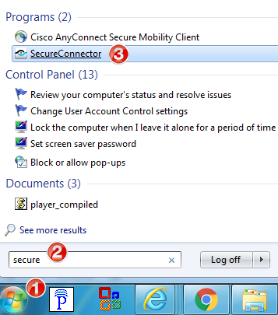 | - Click the Windows Start button  - Click All Programs  - Browse for ForeScout SecureConnector  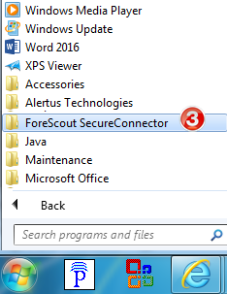

Check a Mac
Open your Applications folder and search for ForeScout SecureConnector.

