- Main Project Settings
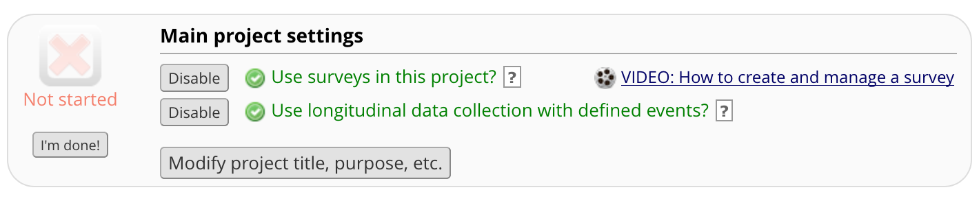

- Event/Instrument Table (longitudinal projects only)
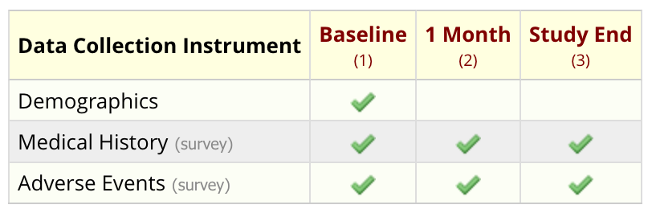

- Survey Settings
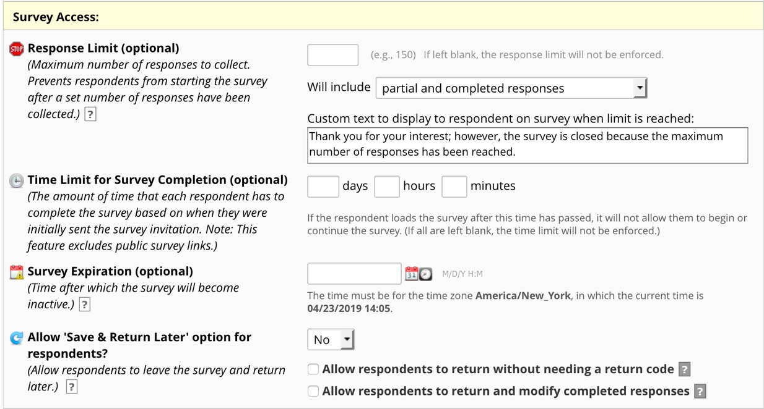

- Optional Modules and Customizations
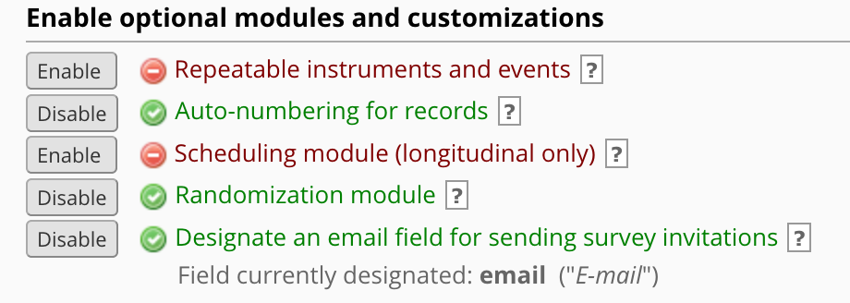

- User Rights and Role

