RPDR Support for Requesting Data using MIDAS tools:
Use Case 1: Finding Accession Numbers
When you have your patient list and know their Patient Medical Record Numbers (MRN) and the site where images were acquired, but you need the Accession Number (unique radiologic imaging study identifier), you can use the RPDR Detailed Data – Using a known list of MRNs request wizard to get the Radiology Test Table that contains Accession Numbers. Note a patient may have multiple imaging studies so you will need to pick the Accession Number corresponding to the specific study you want to retrieve.
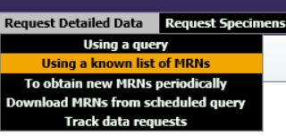

Follow the directions found here (you must be behind the MGB firewall to access): 19. HOW DO I REQUEST IDENTIFIED PATIENT INFO IF I ALREADY HAVE A LIST OF MRNS?. (https://rpdrssl.partners.org/help/faq#19 ). When you get to the step where you are asked to select the types of data you would like returned, specify Radiology Tests (see Figure below). The Accession Numbers for medical imaging studies for the patients in your list will be contained in that table. There will be exceptions, not every medical imaging study has been integrated into the RPDR, but most studies will be there.

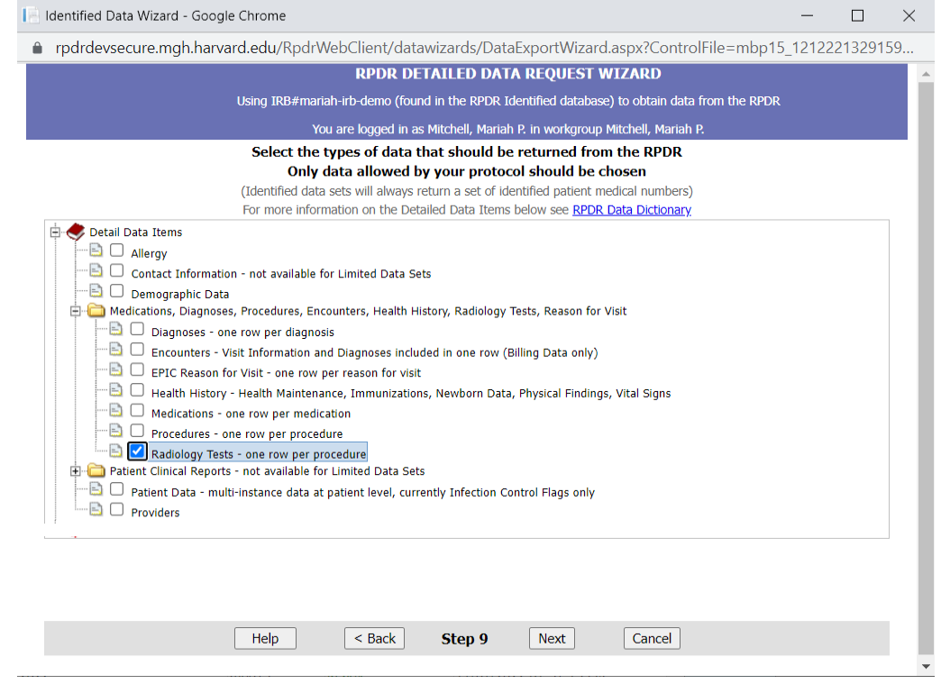
Data Delivery and Filtering
Extracting desired Accession Numbers from the Radiology Tests table or files
Your RPDR data set will be delivered in the form of either an Access database (with accompanying text files) for PC users or, .txt files for MAC users, depending on what you request. The Radiology Tests Table will contain all the radiology studies for each of the patients on your list. You must filter to find the Accession Numbers for the specific imaging studies you want.
For MAC users:
The detailed data set will be delivered in text files (.txt). All radiology tests for the cohort of patients will be delivered in the data set. Importing the data into Excel provides functionality to filter the data to only the radiology tests needed.
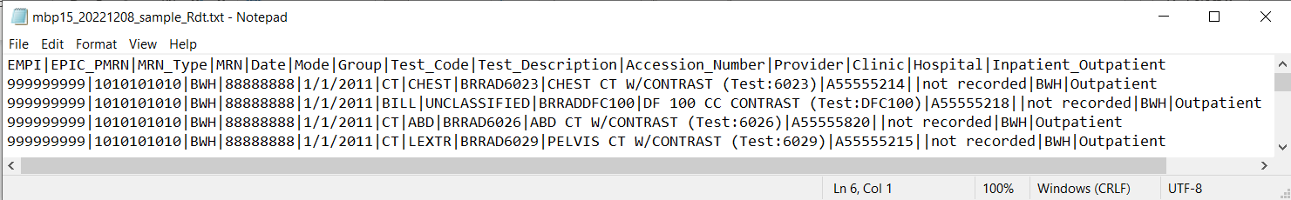

To import data into Excel, select Data -> Get Data -> From File -> From Text/CSV and choose the RadiologyTests.txt file to import.
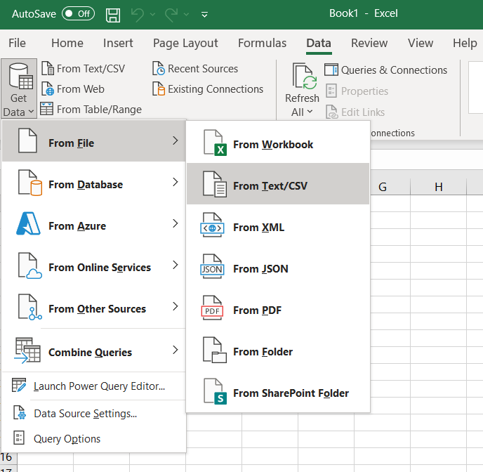

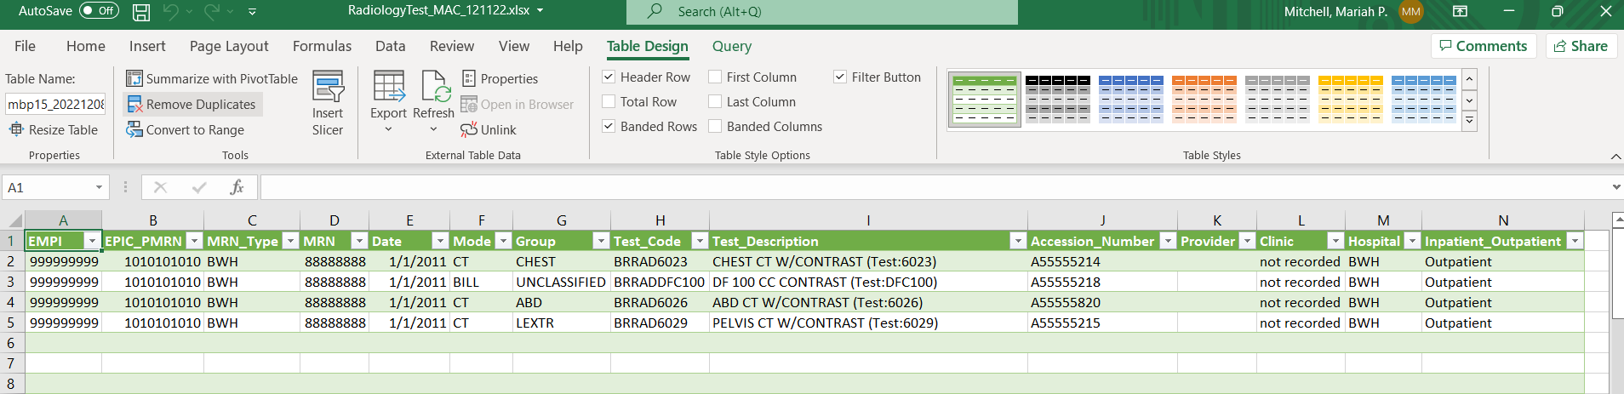

Once loaded into Excel, the data can be filtered to only the radiology tests needed by selecting and toggling thru the options available in the header row (select the down arrow next to the column name in the header row). A good strategy is to begin by selecting a specific Modality using the filter by Mode: (see figure below)

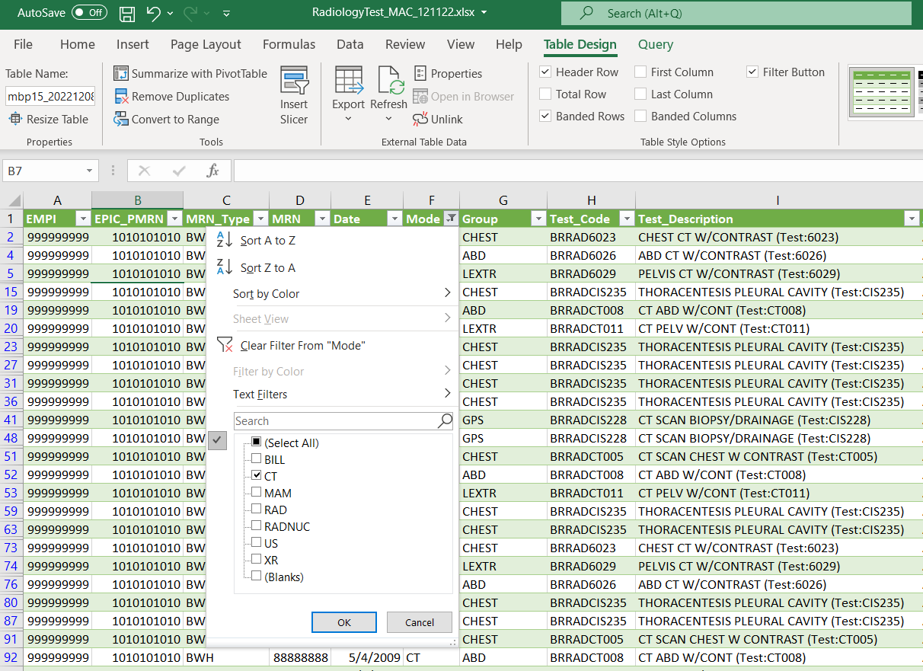
These filtered results can be further filtered using the same procedure. An efficient strategy is to select the down arrow on a different column of the header row to filter by Test_Description and select all the options that describe the type of study in which you are interested: (see figure below).
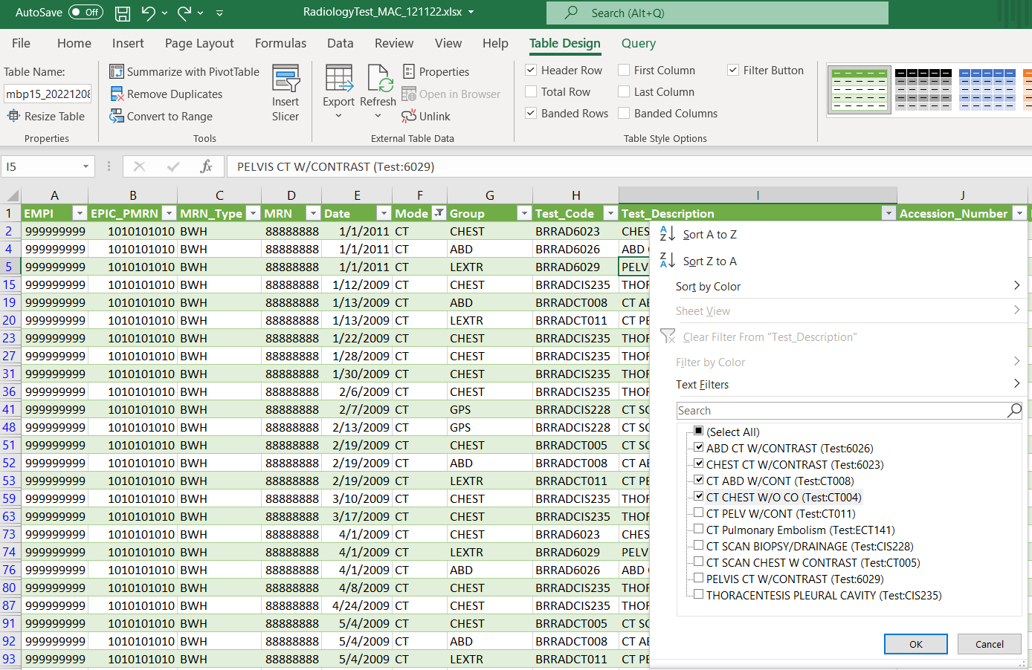
For PC Users:
The detailed data set will be delivered in an Access database with accompanying text files. All radiology tests for the cohort of patients will be delivered in the data set. The data can be filtered to only the radiology tests needed by selecting and toggling thru the options available in the header row (select the down arrow next to the column name in the header row). A good strategy is to begin by selecting a specific Modality using the filter by Mode: (see figure below)
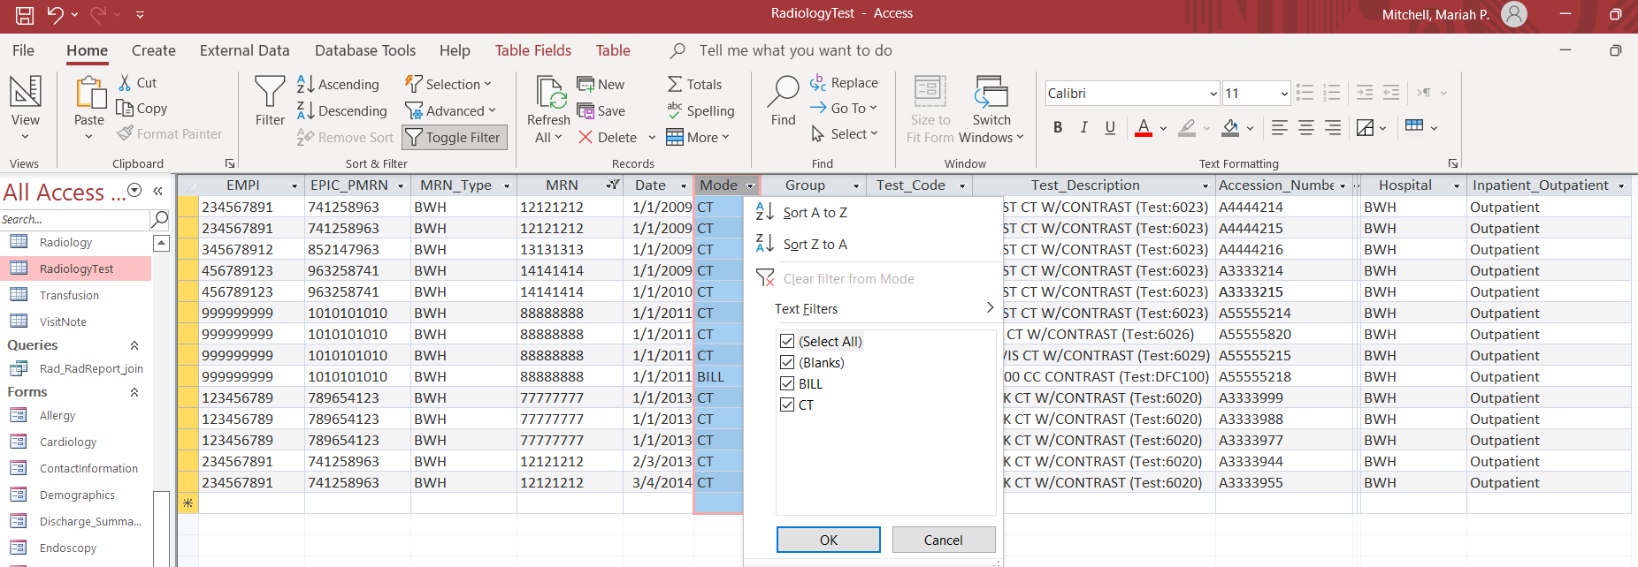

These filtered results can be further filtered using the same procedure. An efficient strategy is to select the down arrow on a different column of the header row to filter by Test_Description and select all the options that describe the type of study in which you are interested: (see figure below).

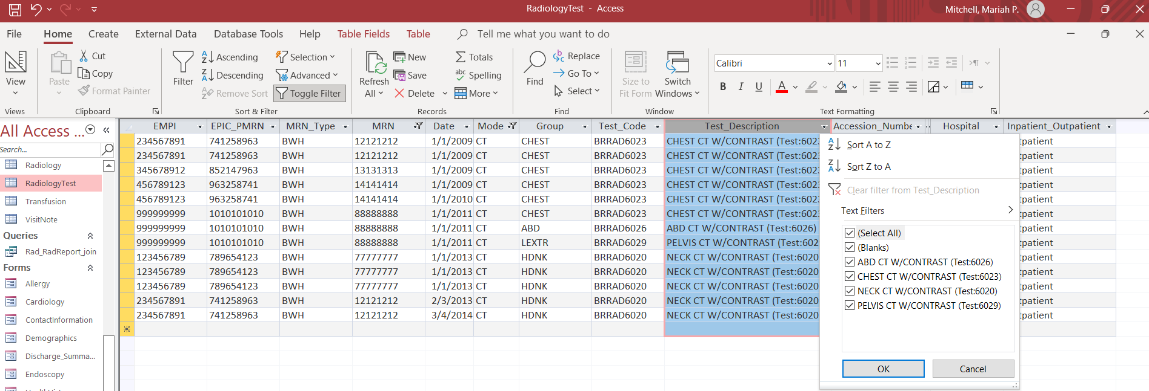

Once you have your studies identified, you can prepare a .csv or .xls file (eg, Microsoft Excel Spread Sheet) of the imaging studies you want to retrieve by selecting External Data -> Excel to export your data to an Excel spreadsheet.
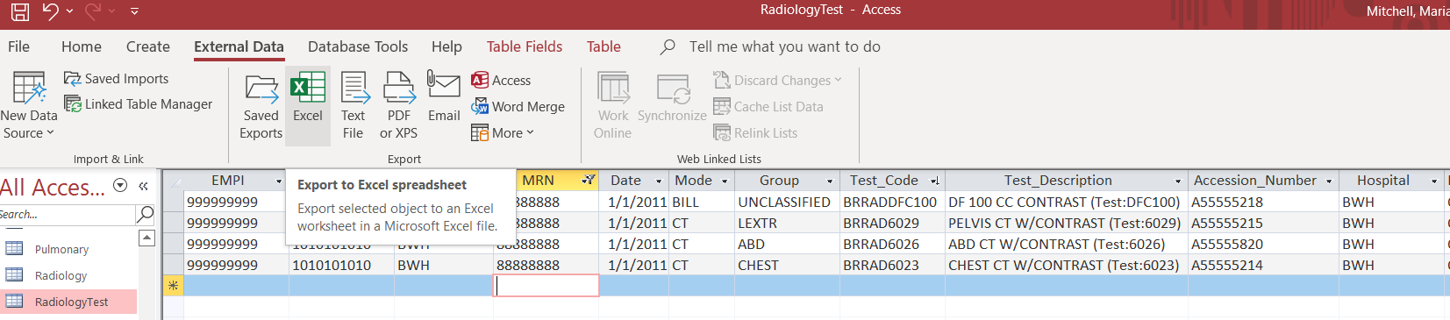

The .csv or .xls file to be prepared for the Medical Imaging Data As A Service (MIDAS) Request Form should contain the following information for each study (3 columns, 1 row per study):
- Patient Medical Record Number (MRN) from site where images were acquired**; DFCI studies should use BWH MRNs
- Accession Number (unique radiologic imaging study identifier)
- Site where the images were obtained (e.g., BWH, DFCI, MGH)
** Note: please use the site MRN – do not submit the patient’s EMPI or PMRN numbers.
RadiologyTest.
EMPI | EPIC_PMRN | MRN_Type | MRN | Date | Mode | Group | Test_Code | Test_Description | Accession_Number | Provider | Hospital | Inpatient_Outpatient
999999999 | 1010101010 | BWH | 88888888 | 1/1/2011 | CT | CHEST | BRRAD6023 | CHEST CT W/CONTRAST (Test:6023) | A55555214 |  | BWH | Outpatient
999999999 | 1010101010 | BWH | 88888888 | 1/1/2011 | CT | LEXTR | BRRAD6029 | PELVIS CT W/CONTRAST (Test:6029) | A55555215 |  | BWH | Outpatient
999999999 | 1010101010 | BWH | 88888888 | 1/1/2011 | CT | ABD | BRRAD6026 | ABD CT W/CONTRAST (Test:6026) | A55555820 |  | BWH | Outpatient
999999999 | 1010101010 | BWH | 88888888 | 1/1/2011 | BILL | UNCLASSIFIED | BRRADDFC100 | DF 100 CC CONTRAST (Test:DFC100) | A55555218 |  | BWH | Outpatient

Use Case 2: MRN, Accession Number, and Site Unknown
The RPDR Query Tool can be used to define the cohort of interest and obtain the variables needed to request medical images using the MIDAS tools. First use the RPDR Query Tool from within the MGB Firewall to define your cohort. Then using the query that created your cohort, request a Detailed Data Set:
To retrieve the Patient Medical Record Number (MRN) from site where images were acquired, Accession Number (unique radiologic imaging study identifier) and Site where the images were obtained (e.g., BWH, DFCI, MGH) for your cohort of interest, you can use the RPDR Detailed Data – Using a Query request wizard. (RPDR Query Tool)
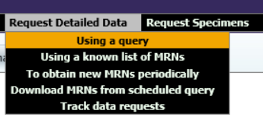

Follow the directions here: 18. HOW DO I REQUEST IDENTIFIED PATIENT INFO USING A QUERY? (https://rpdrssl.partners.org/help/faq#18). When you get to the step where you are asked to select the types of data you would like returned, specify Radiology Tests (see Figure below). The Accession Numbers for medical imaging studies for the patients in your list will be contained in that table. There will be exceptions, not every medical imaging study has been integrated into the RPDR, but most studies will be there. Once you have your RPDR data, follow the directions above for Data Delivery and Filtering.

